Saving resources with EWM
Sustainable = profitable

The original term “sustainability” stems from the old days of forestry where people were warned never to harvest more than the forest could generate.
Today sustainability means much more. It encompasses the meaningful and economical use of all kinds of resources: material, recyclables, energy, even time. In fact, it is often the case that conserving one resource leads to the conservation of many other resources. If less of a material is used, then less of it needs to be produced and processed. It can even save time. Sustainable production, then, is a profitable venture and can save a company many costs. Whether in production, as part of development or in the use of their machines and processes, at EWM AG sustainability is key. Thanks to the holistic approach of the welding manufacturer, from consultation through to its machines and welding processes, customers are able to make the most of their resources in a way that’s both sustainable and profitable.

Putting pedal to the metal with welding technology
Welding process chains, regardless of the industry, offer huge potential for sustainability. As part of the innovation and technology consulting service, ewm maXsolution, specialists from EWM analyse all aspects and influencing factors of the welding process, from construction to production, and strive to optimise the whole process. This includes weld preparation as well as choosing welding consumables and using the best welding process for the job in hand. Even less significant considerations such as gas supply, pre- and post-weld work as well as the use of wear materials are carefully examined. The goal, however, always remains the same: to find the best solution for the customer and the most profitable process. All of these measures together culminate in a sustainable, resource-efficient and consistently high-quality process. The financial expense for any changes often pays for itself through savings made in the process. And what remains, besides these savings, is the good feeling of doing something for the environment.

Save energy
Technology is a crucial factor in the effort to save energy, meaning electricity, in welding technology. This is demonstrated in modern inverter technology, which, in comparison to analogue step switch-controlled transformer power sources, converts the used energy into electricity suitable for the relevant process with a much smaller energy loss. Even more essential are innovative welding processes. Every single welding process is optimally designed for its respective application and applies the used energy in the optimum amount and form to the weld seam. Take a coldArc welding arc, for example, which requires less heat input than a short arc. This saving in energy reduces distortion and, as a result, reduces the amount of post-weld work required. The forceArc puls is, in contrast, a heat-reduced, direction-stable, powerful arc with deep penetration. It even pushes the tinder from untreated black steel forward. The result: high-quality, spatter-free weld seams, saving both weld preparation and post-weld work. This saves energy (electricity and human power) as well as time and material.

Save material
Studies show that multi-layer weld seams save up to 50 per cent on energy by using a smaller preparation angle and a powerul arc. This reduces the amount of degraded metal for weld preparation as well as the number of weld beads. If, however, only half of the material is needed for welding, the welder can create twice as many weld seams with the same amount of material.
Shielding gas also plays a role. A central gas supply in place of using gas cylinders quickly pays for itself. Electronically controlled gas valves save even more gas.

Save time
Optimised welding processes can achieve the same result in less welding time. Many different factors come into play to ensure good, fast and safe working. For example, ergonomically shaped welding torches are easier to work with. An optimised wire feed allows welding consumables to be fed continuously and consistently. Further time can be saved by switching wire electrodes from the roll to a drum connection. The more frequent changing of wire rolls and the disposal of oddments is not necessary – this again saves resources.
Durable wear parts such as power outlets and gas nozzles also save time as a longer service life means they need to be replaced less often. Reductions in time dedicated to switching and replacing parts soon add up.

Look after your health
If users are able to use articulating jib cranes for large components, the need for the often tedious relocation of the wire feeder and hose packages is no more, saving employees both time and preserving their musculoskeletal systems. Innovative welding processes such as forceArc puls and coldArc also reduce welding fume emissions by up to 75 per cent, significantly improving the working conditions and health of welders.

Live for sustainability
Complete customer solutions, effective use of resources and sustainable operations have always been and will always be the focus for EWM – in the development of both its products and processes. This is why EWM is one of the first welding machine manufacturers to pursue inverter technology. Welding machines have continued to become ever smaller, more compact and more practical, allowing us to save valuable resources such as copper and aluminium. But at the Westerwald-based company, sustainability goes much further than the mere construction and use of welding machines. For example, the new administration building has been designed according to the latest advances in building technology. In order to keep the new office complex’s use of primary energy at a very low level, the environmentally-friendly KfW 55 energy standard has been implemented. Inside the building itself, you will also find a very energy-efficient heating system. And now that EWM machines are also being used in the construction of wind turbines, the company has come full circle on sustainability.

Date: 22 May 2019
Size: 6,363 characters including spaces
Figures: 8

Fig. 1:

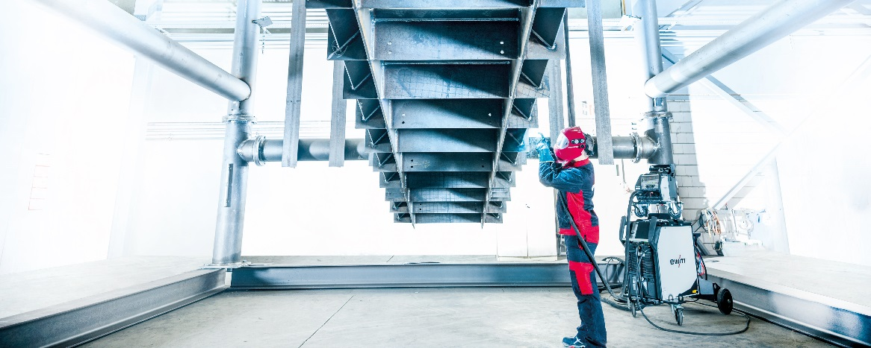
Clean and clever: EWM puts users and customers first when it comes to sustainable complete welding solutions.

Fig. 2:

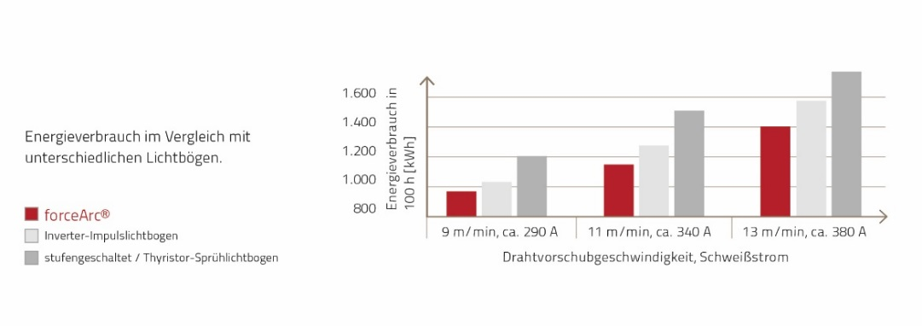
You can save a significant amount of energy with the EWM forceArc welding process.

Fig. 3:

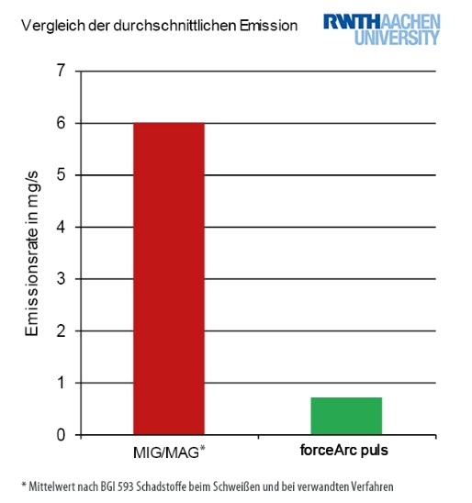

Studies by RWTH Aachen University confirm that the innovative EWM forceArc puls welding process reduces welding fume emissions by up to 75 per cent, preserving the long-term health of the user.

Fig. 4:

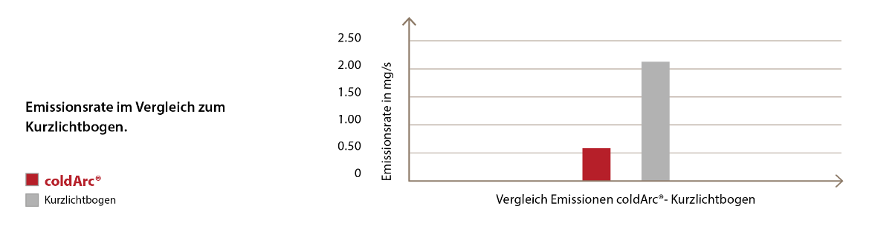

The innovative EWM coldArc welding process also significantly reduces welding fume emissions.

Fig. 5:

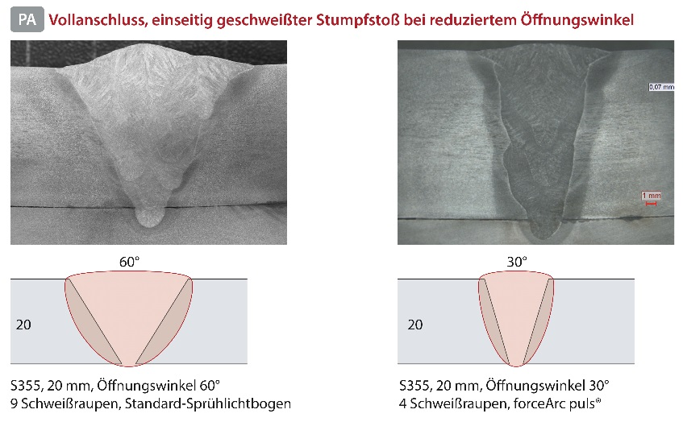

Smaller preparation angles have multiple effects on sustainability: Less material is degraded, pre-weld work is reduced thus saving time. As a result, fewer weld beads need to be welded, saving valuable metals, gas, energy and time.

Fig. 6:

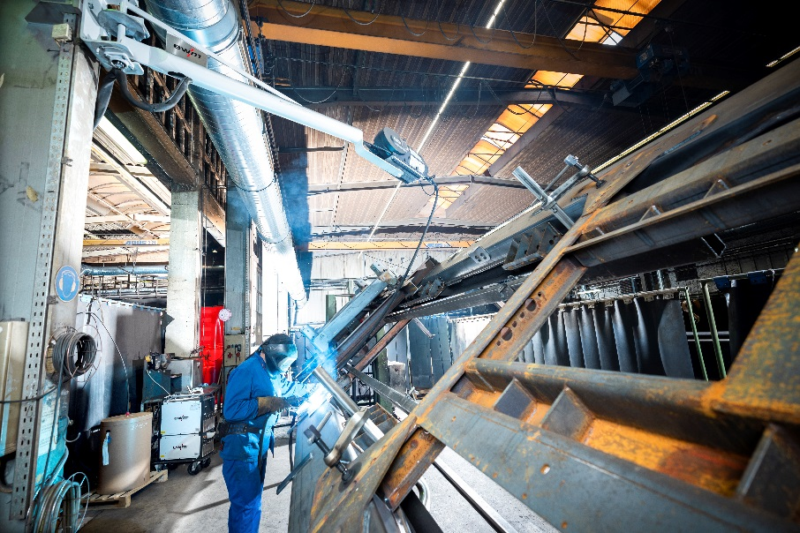

The German market leader for transport and recycling vehicles systems experienced just how big of an impact the EWM holistic approach can have on the sustainability of the workplace. Here EWM was able to reduce gas consumption by a third and working time by 15 per cent. Bonus for the manufacturer: 10 per cent more trailers were subsequently produced.

Fig. 7:

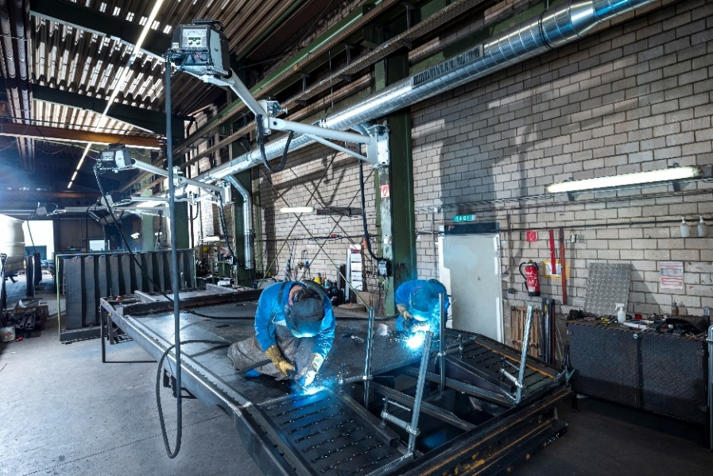

With articulating jib cranes (above), the need for the often tedious relocation of wire feeders and intermediate hose packages around large, awkward workpieces is no more, preserving both the welder’s health and the machine as well as saving time.

Fig. 8:

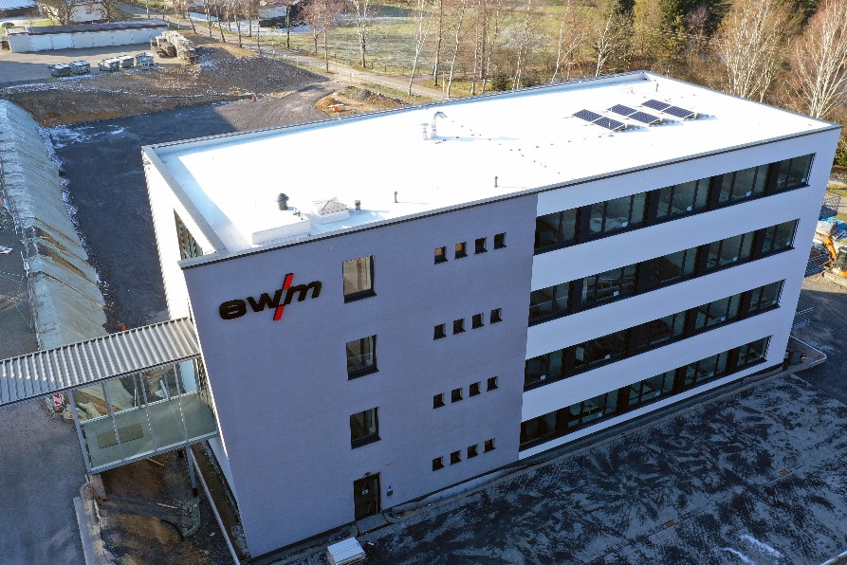

Sustainability is also a key part of the EWM company itself: the new office building in Mündersbach is equipped with a very energy-efficient heating system as well as ergonomic furniture.

About EWM:
EWM AG is Germany’s largest and one of the most important worldwide manufacturers of arc welding technology. The family-run company from Mündersbach has been living its motto, “WE ARE WELDING”, with a great deal of passion for over 60 years, providing forward-looking and sustainable complete solutions for both industrial clients and craft businesses.
EWM develops high-end welding technology. The company, based in Germany’s Westerwald region, offers complete systems that cover everything from high-quality welding machines (and all associated components) to welding torches, welding consumables and accessories for manual and automated applications.
Users praise the products’ ease of operation and excellent results. Companies value the solid consultancy, service and enormous savings that come with EWM systems. The welding processes, some of which are patented, reduce the consumption of materials, energy and time during operation and produce up to 75 per cent fewer welding fume emissions.
The innovative welding technology manufacturer currently employs around 800 employees at 14 German and 7 international locations, with just under 400 based at its original headquarters in Mündersbach.

EWM AG company contact
Maja Wagener
Dr.-Günter-Henle-Str. 8
56271 Mündersbach, Germany
Telephone: +49 2680 181-434
Email: maja.wagener@ewm-group.com
Internet: www.ewm-group.com

Press contact
additiv pr GmbH & Co. KG
Jan Leins
Public relations for logistics, steel, industrial goods and IT
Herzog-Adolf-Straße 3
56410 Montabaur, Germany
Telephone: +49 2602 950 99-16
Email: jl@additiv-pr.de
Internet: www.additiv-pr.de

