EWM AG celebrates summer party in Wittstock
Welding technology expert draws positive results since site opening

It is just short of one year since EWM AG opened its new site in Wittstock, hoping to capitalise on the large demand for innovative welding solutions in northeast Germany as the country’s largest arc welding technology supplier and world leader for technology. Reflecting on the past months, Martin Schumacher from EWM appeared positive: The feedback from customers has been overwhelmingly positive and the employees are enjoying the great working conditions. In fact, the company could even employ more people at the site. EWM will be celebrating this on Friday, 7 June, with a summer party and big discounts.

Martin Schumacher, office manager at the EWM Wittstock site, reflects positively on the months following the opening of the new site: “The feedback from our customers has been overwhelmingly positive. We were able to gain some new customers and will continue to do so.” It’s a similar story for employees too. Since the opening in September 2018, eight new employees have joined the EWM team in Wittstock. “The feedback from employees has also been really positive and the amazing working conditions are clear to see in the day-to-day work,” Schumacher happily reports. Schumacher also highlights the great application technology and service opportunities and the new site’s ideal transport accessibility.

Up to 70 per cent discount on machines
EWM will be celebrating with a summer party on Friday, 7 June, from 12 to 5 pm at the Wittstock site (Ruppiner Straße 6). Customers, employees, anyone who is interested from the region – everyone is invited. There will be an employee-guided plant tour and a tombola. There will also be a clearance sale of display and hire machines at special prices with discounts of up to 70 per cent.

Date: 28 May 2019
Size: 1,958 characters including spaces
Figures: 2 (Source: EWM)

Fig. 1:

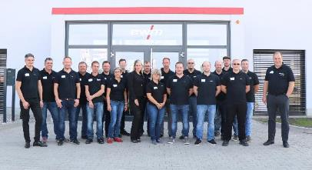

The EWM AG team at the Wittstock site: The welding technology manufacturer started with 14 employees. Eight new employees have since joined the team, which aims to grow to up to 40 employees.

Fig. 2:

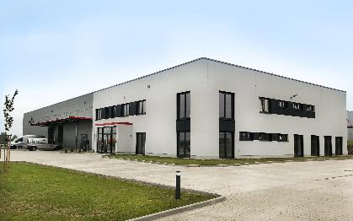

EWM AG has invested 3.8 million euros into the new sales and technology centre in Wittstock. In the conveniently located new building, the family-run company provides a comprehensive range of arc welding technology across 2,000 square metres.

About EWM:
EWM AG is Germany’s largest and one of the most important worldwide manufacturers of arc welding technology. The family-run company from Mündersbach has been living its motto, “WE ARE WELDING”, with a great deal of passion for over 60 years, providing forward-looking and sustainable complete solutions for both industrial clients and craft businesses.
EWM develops high-end welding technology. The company, based in Germany’s Westerwald region, offers complete systems that cover everything from high-quality welding machines (and all associated components) to welding torches, welding consumables and accessories for manual and automated applications.
Users praise the products’ ease of operation and excellent results. Companies value the solid consultancy, service and enormous savings that come with EWM systems. The welding processes, some of which are patented, reduce the consumption of materials, energy and time during operation and produce up to 75 per cent fewer welding fume emissions.
The innovative welding technology manufacturer currently employs around 800 employees at 14 German and 7 international locations, with just under 400 based at its original headquarters in Mündersbach.

EWM AG company contact
Maja Wagener
Dr.-Günter-Henle-Str. 8
56271 Mündersbach, Germany
Telephone: +49 2680 181-434
Email: maja.wagener@ewm-group.com
Internet: www.ewm-group.com

Press contact
Jan Leins
additiv pr GmbH & Co. KG
Public relations for logistics, steel, industrial goods and IT
Herzog-Adolf-Straße 3
56410 Montabaur, Germany
Telephone: +49 2602 950 99-16
Email: jl@additiv-pr.de
Internet: www.additiv-pr.de

